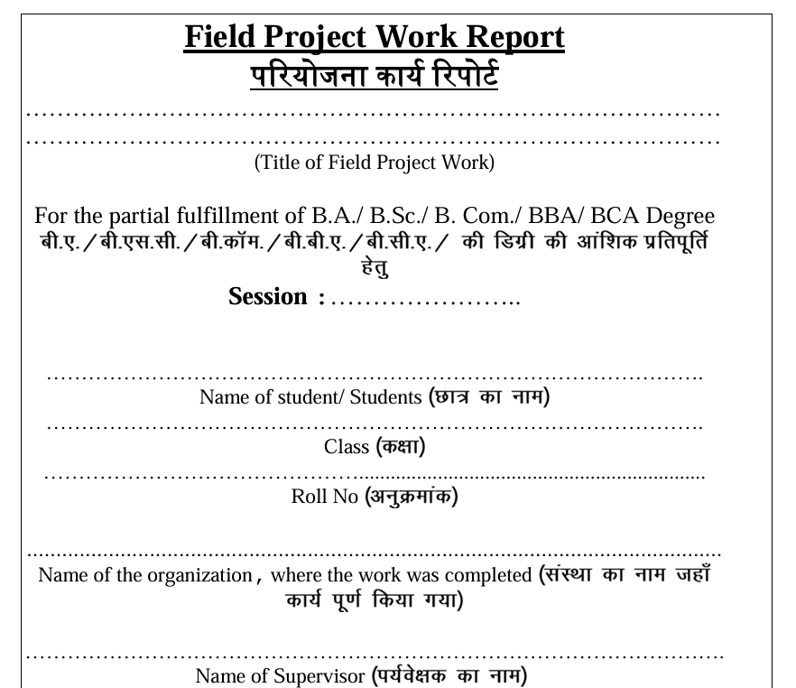

Submitted By
Student Name: …………………………………………………………………
Enrolment: ………………………………………………………………………
Course Name: ……………………………………….…………………………

For the fulfilment of undergraduate courses running as per
National Education Policy 2020
by
Madhya Pradesh Higher Education Department

Under the Supervision of
Name: …………………………………………………………………..
Designation: ………………………………………………………….
Department: …………………………………………………………

DECLARATION BY THE STUDENT
Project Title:
………………………………………………………………………………………………………………………………………………………………………………………………….………………………………………………………………………………………..…
I,………………………………………… (Enrolment:……………………………. ), certify that this field project is my own work, based on my personal study and/or research and that I have acknowledged all material and sources used in its preparation, whether they be books, articles, reports, lecture notes, and any other kind of document, electronic or personal communication. I also certify that this project has not previously been submitted for assessment in any academic capacity, and that I have not copied in part or whole or otherwise plagiarised the work of other persons. I confirm that I have identified and declared all possible conflicts that I may have.

Signature: ……………………………………………..
Date: ……………………………………………………..
Location: ………………………………………………..

CERTIFICATE OF THE SUPERVISOR

It is certified that the project report entitled “………………………………………………..…
……………………………………………………………………………………………………… ” is a piece of field project work done by Mr/Mrs/Ms. ……..………………. ………………………………..…(Enrolment ……………………………………) under my guidance and supervision for the degree of ……………………. in year………………… to be awarded by Awadesh Pratap Singh University, Rewa, Madhya Pradesh, India and that the student has put the attendance at work place. To the best of my knowledge and belief this report embodies:
I. the work of candidate by himself / herself,
II. has duly been completed,
III. fulfills the requirements of the NEP 2020 related to degree of the University
IV. is upto the standard in respect of both content and language.
V. Contents of the report do not form the basis for the award of any other degree/ diploma or similar title to the candidate or to anybody else from this or any other University/College.

Signature of the Supervisor
Name: ………………….…………………..
Date: ……/…../………….
Location: ………………………………….

ACKNOWLEDGEMENT

Signature: ……………………………………………..Date: …..…/…………/……………
Student Name: ……………………………………. Enrollment………………….……….

CONTENTS
